|  |
| --- |
| Referral System  Technical Document  Last modification: 14 June 2012  Ly Channa & Lim Chanman |

Table of Contents

1. Overview 3

2. Goal 3

3. System architectures 4

3.1 Message Flow for Private provider 4

3.2 Message Flow for Health Center 4

4. Functionalities summary 4

4.1. Dynamic variables 5

4.2. Dynamic variables constraint 5

4.3. Dynamic Message Formats 6

4.4. Message Templates and Translations 6

4.5. User Management 6

4.6. Report Management, Report Export, Report simulation 6

4.7. Message Gateway 6

4.8. Alert system 9

5. Technical Summary 10

5.1. Technologies Selection 10

5.2. Database schema 11

5.3 Data Dictionary 11

5.4 Configuration 13

5.5 Installation 13

5.6 External Libraries 13

# Overview

# Goal

# System architectures

Referral System controls the messages sending from Private provider and Health Center. The overall system might look like below:

## 3.1 Message Flow for Private provider

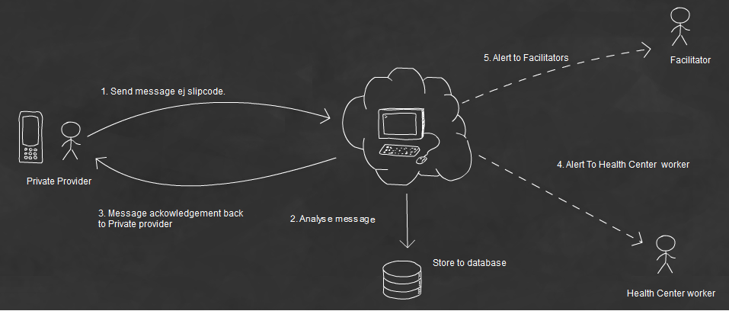

Fig. 1: Message sent from private provider

## 3.2 Message Flow for Health Center

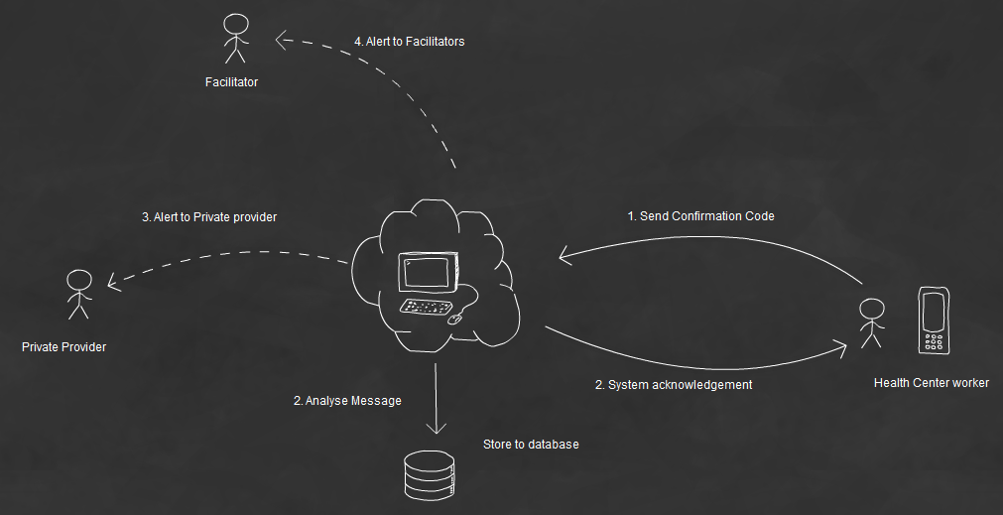

Fig. 2: Message sent from Health Center

# Functionalities summary

Below are the requirement functionalities of the Referral System:

* Dynamic variables
* Dynamic variable constraints
* Dynamic message formats
* Message template
* User management
* Report Management and Data export
* Message Gateway
* Alert System

## Dynamic variables

Enable referral system to create “**Dynamic variables****”** used to construct “**Message Format****”** for Private provider and Health Center SMS syntax. Each of “**Dynamic Variable**” is then mapped to a specified field in Referral report in which it will be stored to.

## Dynamic variables constraint

Used to create validation for a “**Dynamic Variable****” .** It is the one who decides whether the dynamic variable is valid or invalid by validating the “**Dynamic variable**” again it constraint.

## Dynamic Message Formats

Enable Referral System to construct **Message Format** for Private Provider and Health Center. It is constructed from various static built in variables and dynamic variables. Dynamic message is the core syntax for parsing SMS sending from both private provider and health center. Referral System analyses the SMS by parsing each pieces of SMS validating again the message format and store in Referral report.

## Message Templates and Translations

All the Alert SMS to every party in Referral System are store here. Message template contains plain text and parameters to be translated in real time by Referral report.

Referral report read the message template and translates it with its own field value that matches again the message template parameter. After the message is being translated, It is used as the content of alert SMS to alert to different party in the Referral System.

## User Management

Manage Referral user and also Allowing MD0 user to be register to Referral System as well by searching through the MD0 user.

## Report Management, Report Export, Report simulation

Allow Referral System to manage reports sending from both Private provider and health center. It can be filtered by various criteria and also allow reports to be searched, exported as CSV.

Report can also be simulated. The idea of simulation is to allow Referral system administrator to test the parser constructed in dynamic message format in real quick way without touching real phone SMS.

## Message Gateway

Message Gateway is the core part of Referral system to route the SMS sending from both MD0 and Referral user. It analyses, route, store and alert to a right application (Referral or MD0).

Behind the scene Message Gateway checks the sender address to see the application in which the sender registered to. 3 scenarios are studied here:

1. Sender registered to only MD0: The MD0 parser will be used, analyzed and then store report to MD0 report and alert to MD0 parties.
2. Sender registered to only Referral: The Referral parser will be used , analyzed and then store report to Referral report and alert to Referral parties
3. Sender is registered to both MD0 and Referral: Message Gateway will try to parse the SMS message again Referral parser if it fails then it will try to parse again MD0 parser. If both are failed then it will check to get the better parser – the less error encounter in the parser result is the better.

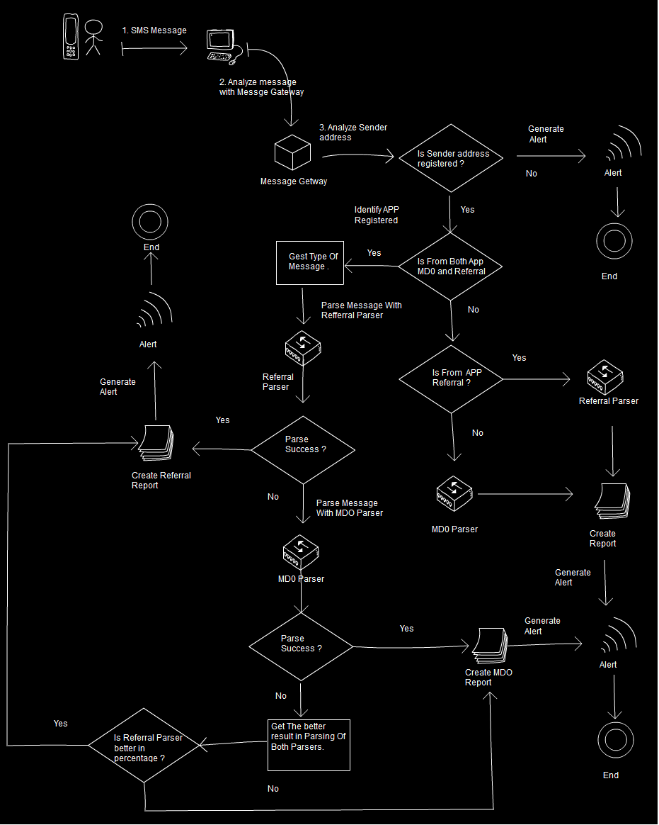

Fig. 3: How “Message Gateway” handles SMS

## Alert system

Alert system is responsible to alert each party of Referral System. The Alert depends on the role of the sender and the message sent.

There are 2 alerts:

1. Private provider alert
2. Health center alert

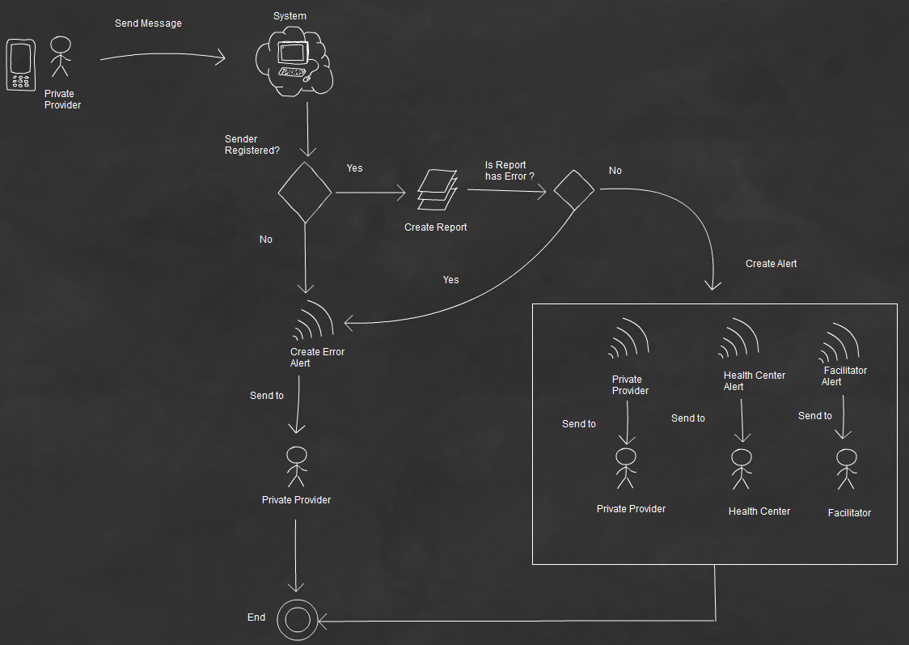

Fig. 4: SMS Alert for private provider

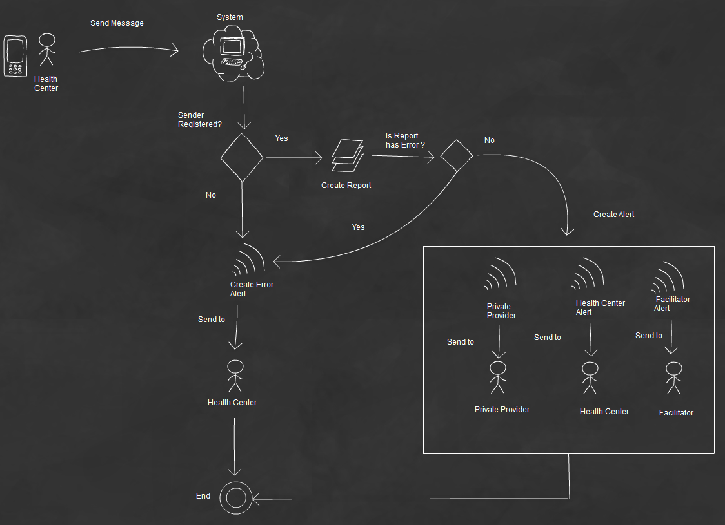

Fig. 5: SMS alert for Health Center

# Technical Summary

## Technologies Selection

As having been considered already in Malaria Day Zero system, Referral system is just an extra module built on top of Malaria Day Zero system. Malaria Day Zero system is being implemented in the following technologies: Linux, [RubyOnRails](http://php.net/), [Apache HTTP Server](http://httpd.apache.org/) , [MySQL Database Server](http://www.mysql.com/downloads/mysql/).

## Database schema

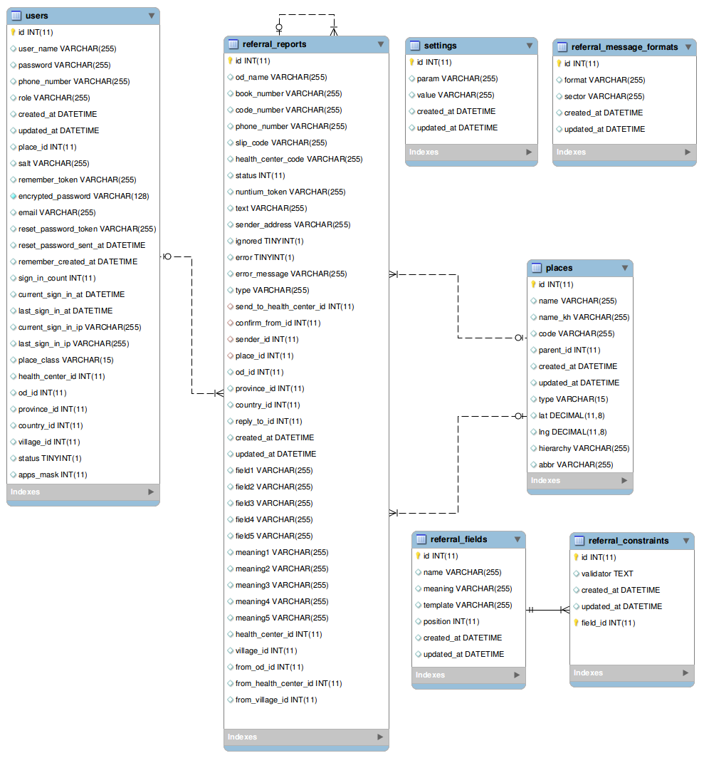

Fig. 6: Referral System database schema

## Data Dictionary

users: Represent the user in the system

* user_name (varchar) : store name of the user register.
* Password : store password of the user used along with email when user need to login to use the system
* email: used as the login for the system in combination with password.
* phone_number: use to enable user to report via sms
* role : role of the user. Role is devided into 2 groups

Md0: (ROLE_MC_DEFAULT, ROLE_MC_NAT , ROLE_MC_ADMIN)

Referral: (ROLE_REF_PROVIDER, ROLE_REF_FACILITATOR, ROLE_REF_HC)

* place_id : place where the user located in
* status : the status of the user. In order to be able to report the status must be ACTIVATE

0 represents DEACTIVATE

1 represents ACTIVATE

* app_masks : Bit mask represents whether the user is register to MD0 and/or Referral System.

First bit active represents Mdo.

Second bit active represents Referral System.

referral_reports: Represent all the referral reports

* od_name(varchar) : store the abbreviation name of the od sent by health center or private provider. It is the first part of slip_code. Ej **mr**001100
* book_number(varchar) : store the book number of the slip_code. Ej mr**001**100
* code_number(varchar): store the code number of the slip_code. Ej mr001**100**
* slip_code (varchar) : store the slip_code containing od_name, book_number and code_number . Ej **mr001100**
* health_center_code (varchar) : store health_center code used in message format.
* nuntium_token (varchar) : GUID of sms message
* text (varchar) : store the whole text message in sms message
* sender_address (varchar) : store the sender phone_number
* ignored (Boolean) : mark if the message is ignored.
* error(Boolean) : mark if the message has error.
* error_message (varchar) : store error type when parse message again the parser
* type (varchar) : specify the type of report. Can be HCReport or ClinicReport
* send_to_health_center_id (int) : link to the health_center_id if the clinic specifies the health_center_code in the message
* confirm_from_id (int): store the health_center report id when the healthcenter confirmed the clinic report by sending back the slip_code of the referred patient.
* place_id : store place of the sent-out report.
* od_id : store the od of the sent-out report
* province_id : store the province of the sent-out report
* country_id : the country of the report
* field1, field2,field3, field4, field5 : are reserved for dynamic variables
* meaning1, meaning2, meaning3, meaning4, meaning5 : denormalised meaning of the dynamic variables used in field1, field2,field3, field4, field5.

settings: represents the message template setting

* param : Parameter name used in the message template.
* value : value represents for the parameter

referral_message_formats: represents the dynamic message format for health center and clinic

* format : The message format of health center or clinic
* sector : specifies whether the message_format belongs to Health center or Clinic

referral_fields: represents the dynamic variables of referral system.

* name: the name map to the field in referral reports. Its value can be field1, field2,field3,field4 or field5. It is used for readability only.
* meaning: the current meaning of the dynamic field
* position: is the position of the dynamic field located inside the referral reports. Possible value: 1,2,3,4,5. This field is used to calculate the field map in referral reports instead of the “name” field.

referral_constraints: represents the constraint of the dynamic field.

* validator : the name of validator used as constraint for dynamic field. Currently referral system support between, max, min, collection, different_from, equal_to, start_with, length.
* field_id: the id of the dynamic field to be applied the validator.

## Configuration

There is no special configuration for this module.

## Installation

Just like MD0 system.

## External Libraries

No extra external library is used beside existing library used in MD0 System.